**HOTEL RESERVATION ANALYSIS FROM JUNE 2015 - SEPTEMBER 2017**

The dataset contained in a csv file contains information about customer reservations for two hotels (City hotel and Resort hotel) from June 2015 - September 2017. It has 119390 rows and 32 columns. Below is the dataset as seen in Microsoft excel:

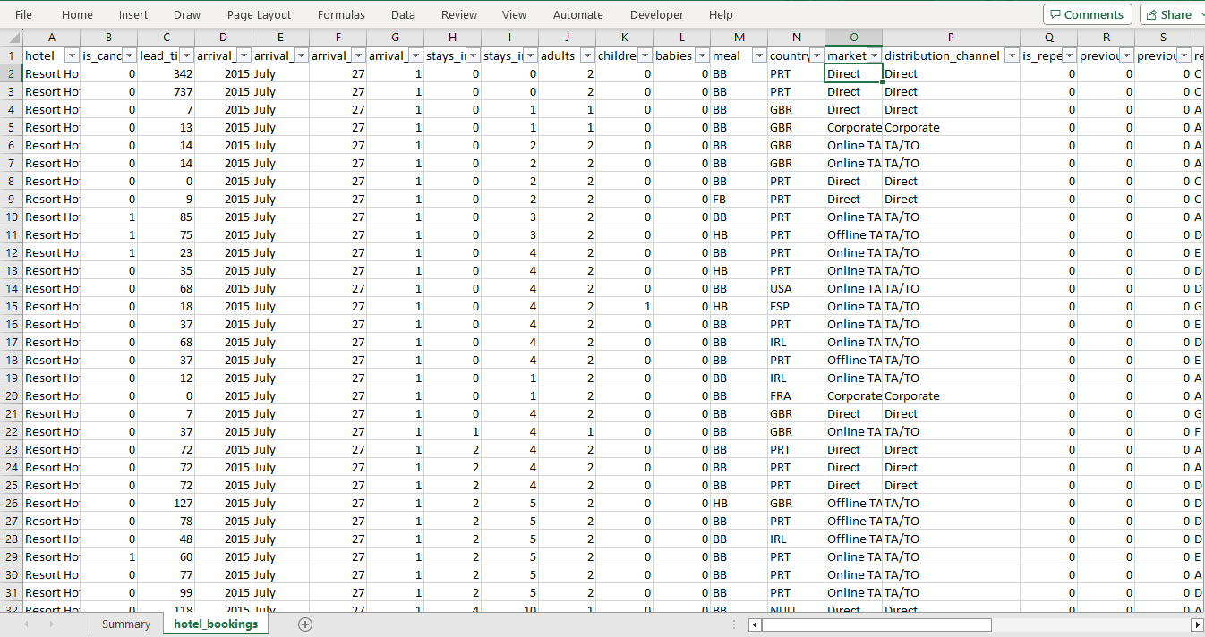

The tools used for the analysis are Tableau prep builder for data manipulation and tableau public for analysis and data visualization.

**For the data manipulation**, I converted the 1 and 0 to "yes” and “no” in both the “is canceled column” and the “is repeated guest” column for better understanding of the data. I changed the column header “is canceled” to “cancelled booking?”, “stays_in_weekend_nights” to “no of weekend nights”, “stays_in_week_nights” to “no of week nights”, “meal” to “type of meal booked”, “booking_changes” to “n of booking changes”, “agent” to “travel agency ID”, “adr” to its full meaning “avg daily rate”, “required_car_parking_spaces” to “no of parking spaces”. I added prefix “no of” to adults, babies, and children column headers. I created a column named “arrival date” using 3 columns (arrival date day of month, arrival date month, arrival date year) and I deleted the column named “company” since I would not be needing it for the analysis.

After data manipulation, I saved the flow file on the tableau prep and loaded it into tableau public where I did the Data visualization.

The loaded data is below:

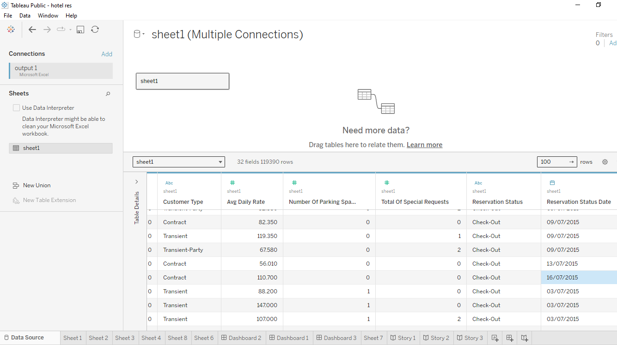

During the analysis, I deduced that:

* City hotel had more customers spread out across 41 more countries than the Resort hotel and by extension more revenue.

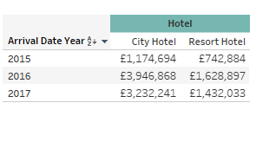

* The year 2016 was the best year for the hotels regarding their revenue which in total was more than 5M GBP.
* Most of the customers are first-timers and many parents prefer the bed and breakfast type of booking to the others.
* Travel agency 9 made the most customers than other travel agencies.

After loading the data, I began the analysis and data visualization. The analysis can be seen in the visualizations below:

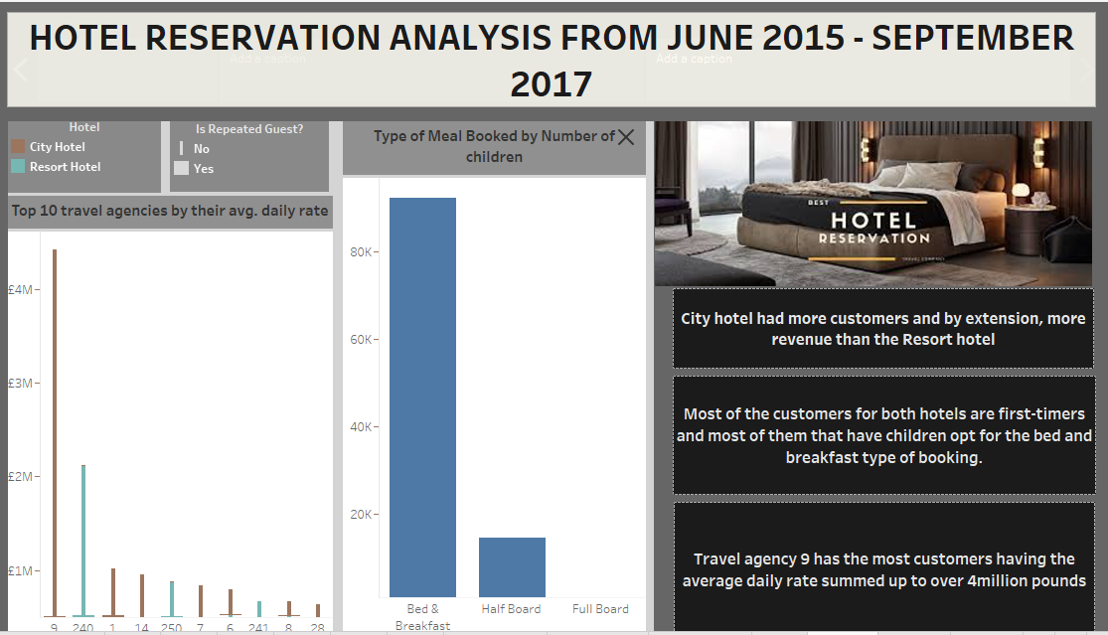

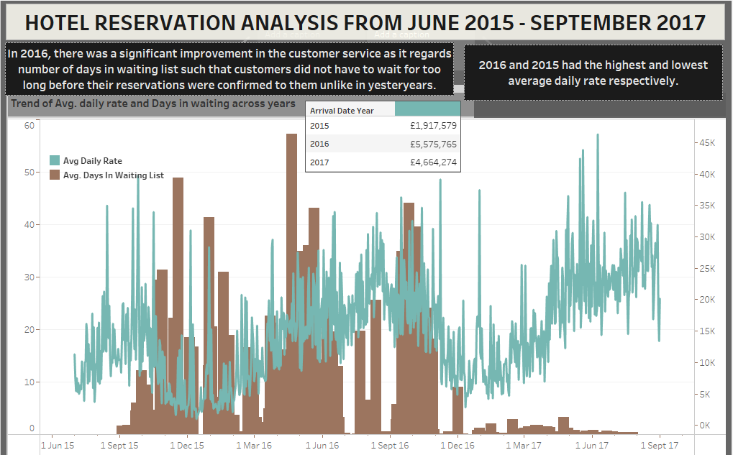

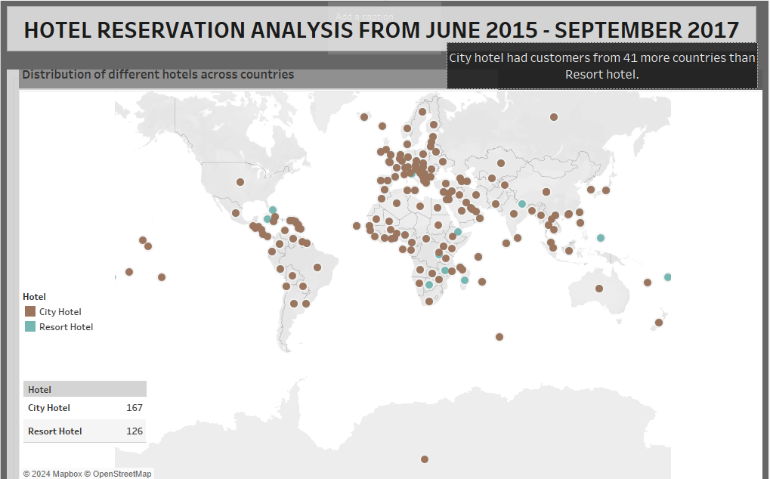

After the visualization, the workbook was publish to the tableau public having this url: <https://public.tableau.com/app/profile/chidinma.uzonwa/viz/hotelreservationanalysis_17050832648900/Story1#1>

**RECOMMENDATION**

Since most of the customers are first-timers, it can be deduced that something about the service makes many customers refuse to come back after the first stay. Therefore, a feedback can be gotten from customers to help the hotels serve them better and by extension, increase revenue.